
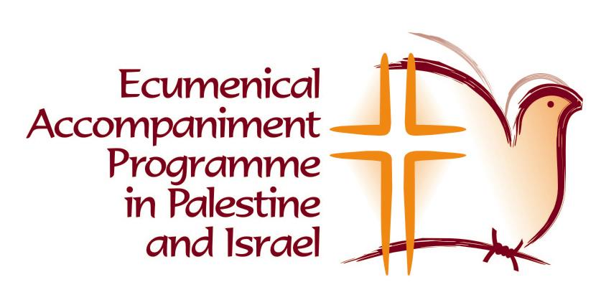
World Council of Churches

EAPPI - Reference Form

INSTRUCTIONS TO PROSPECTIVE ECUMENICAL ACCOMPANIERS:
Give this form to three (3) people (non-relatives) you have chosen to be your referees and
ask them to send the original completed EAPPI Reference Form to the EAPPI National Coordinator in your country, where you have submitted the EAPPI Application Form.

Dear referee,

Thank you for agreeing to appraise a candidate for participation in the Ecumenical Accompaniment Programme in Palestine and Israel (EAPPI).

The EAPPI is an ecumenical initiative whose mission is to accompany Palestinians and Israelis in their non-violent actions and concerted advocacy efforts to end the occupation. Participants of the programme will be monitoring and reporting violations of human rights and international humanitarian law, supporting acts of non-violent resistance alongside local Christian and Muslim Palestinians and Israeli peace activists, offering protection through non-violent presence, engaging in public policy advocacy and, in general, standing in solidarity with the local churches and all those struggling against the occupation.

The EAPPI is based on principles of international humanitarian and human rights law, including resolutions of the UN Security Council, General Assembly and Commission on Human Rights. Its detailed objectives are to: expose the violence of the occupation; end the brutality, humiliation and violence against civilians; construct a stronger global advocacy network; ensure the respect of human rights and international humanitarian law; influence public opinion in the accompaniers' home countries and affect foreign policy on Middle East in order to end the occupation and create a viable Palestinian state; express solidarity with Palestinian and Israeli peace activists and empower local Palestinian communities/churches; be an active witness that an alternative, non-violent struggle for justice and peace is possible.

Given this challenging mandate and the gravity of the current situation on the ground it is absolutely crucial that participants bring well-developed skills to the project. We are especially interested in any insights that you can provide related to the candidate's skill and proficiency in the areas of peace and solidarity work, human rights, reporting and advocacy, non-violence and conflict resolution.

Whether working on their own, with the rest of the EAPPI team or with locals, daily life on the ground could be very stressful for the accompaniers. Peace and justice work in Israel/Palestine often may take place in an atmosphere of tension, fear, confrontation and violence, with curfews, checkpoints and other military controls having become common features of everyday life. Ecumenical Accompaniers will also be expected to deal with diverse parties such as the local and international media, military authorities, church leadership and even groups hostile to their very presence. Their work will therefore demand a high degree of sensitivity, initiative, political awareness, tolerance, flexibility, cultural understanding, ability to work with others, good human relations and excellent communication skills.

We would appreciate your candid appraisal of the candidate's ability to work with the Ecumenical Accompaniment Programme in Palestine and Israel. In the enclosed reference form, we have outlined specific areas upon which we would like you to comment. Please add to these responses any additional comments that you may feel are relevant.

Sincerely,

EAPPI Coordination
----------------------------------
World Council of Churches

EAPPI - Reference Form

- Name of Candidate:

- How long have you known the candidate and in what capacity?

- Please comment briefly on the candidate's:

A. Ability to take responsibility and follow through;
Self-motivation or initiative;
Group facilitation/leadership skills;
Ability to handle interpersonal tension;
Ability to live and work in a foreign cultural environment and in a conflict situation;

B. Ability to speak, write and understand English and Arabic (if applicable);
Writing and reporting skills;
Objectivity in seeking and interpreting information;
Experience in advocacy work;

C. Knowledge and experience of Palestinian and Israeli history and politics; Understanding of and commitment to the principles of non violence; Knowledge of human rights, international law and international humanitarian law;

D. Ability to work with others, in a group, and in a team;
In a group, is s/he a leader; a peacemaker; supportive of others; a follower; frequently at odds with others?
How does the candidate deal with people s/he does not agree with?

4. Please comment on any other strengths and weaknesses you have seen in the candidate:

Referee's Name:

Address:

Telephone:

Email:

Signature:

Date and place:

Thank you for taking the time to tell us more about this candidate. If s/he is accepted, we may want to talk with you further.

Please tell us the best time to call:

